🧪 Practice Set (this is what you asked for)
Do these in order. This covers 80% of what they expect.

✅ Task 1: Core React Component Design
Problem
Create a User List Component
Requirements:
- Fetch users from API:
- https://jsonplaceholder.typicode.com/users
- Display:
  - Name
  - Email
- Add:
  - Loading state
  - Error state
What they check:
- useEffect + useState
- Clean JSX
- Proper conditional rendering

✅ Task 2: Component Structuring
Problem
Refactor above into:
- UserList
- UserCard
Add:
- Props typing (TypeScript)

✅ Task 3: State Management Thinking
Problem
Add:
- Search input
- Filter users by name
What they check:
- Where state should live?
- Controlled inputs
- Derived state

✅ Task 4: API Integration (Real-world level)
Problem
Convert API logic into:
/services/userService.ts
Requirements:
- Create reusable API function
- Handle errors gracefully

✅ Task 5: Performance Optimization
Problem
Optimize your app:
- Prevent unnecessary re-render of UserCard
Expected concepts:
- React.memo
- useMemo / useCallback

✅ Task 6: Form Handling (VERY IMPORTANT)
Problem
Create Add User Form
Fields:
- Name
- Email
Requirements:
- Validate email
- Show error messages
- Add new user to list

✅ Task 7: Testing (basic is enough)
Problem
Write test for:
- UserList loads data
- Search works
Use:
- React Testing Library

✅ Task 8: UI Library exposure (optional)
Use MUI:
- Replace plain HTML with:
  - Cards
  - TextField
  - Button

Answers

🚀 FRONTEND LAB 1 — React Fundamentals (Step by Step)

🧪 Problem
Build a User List UI
API:
https://jsonplaceholder.typicode.com/users

✅ Step 1: Create Project (Vite – since you use it)
Run:
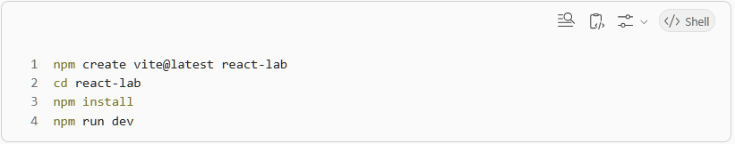
✅ Step 2: Clean project
Inside App.jsx → remove everything

✅ Step 3: Basic Component Setup
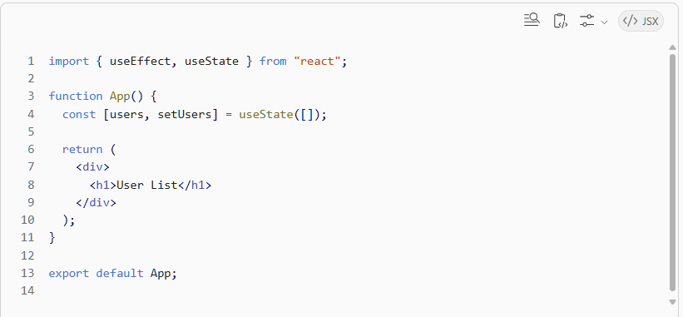
✅ Step 4: Add API call
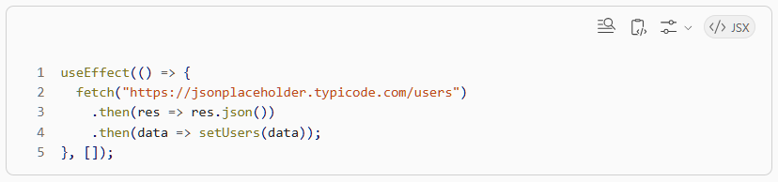
✅ Step 5: Render users
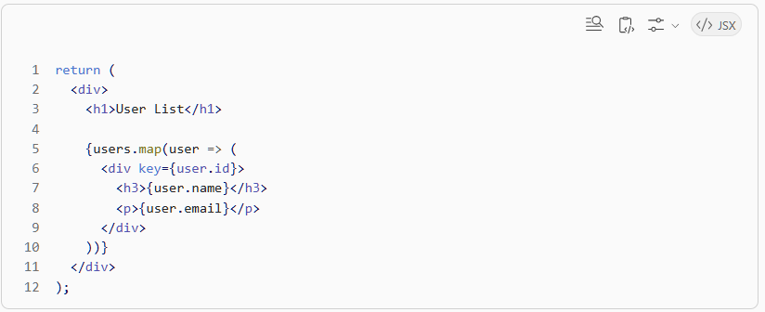
✅ Step 6: Add loading state (INTERVIEW IMPORTANT)
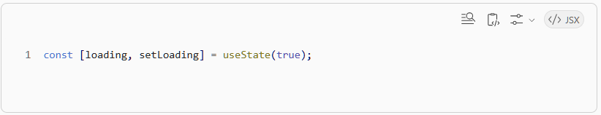
Modify fetch:
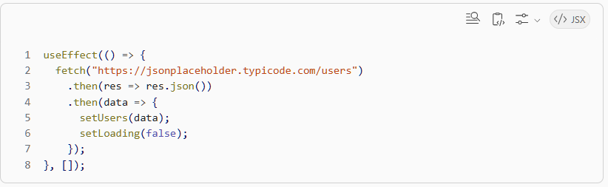
Render:
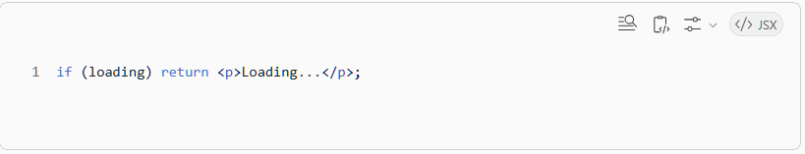
✅ Step 7: Add error handling
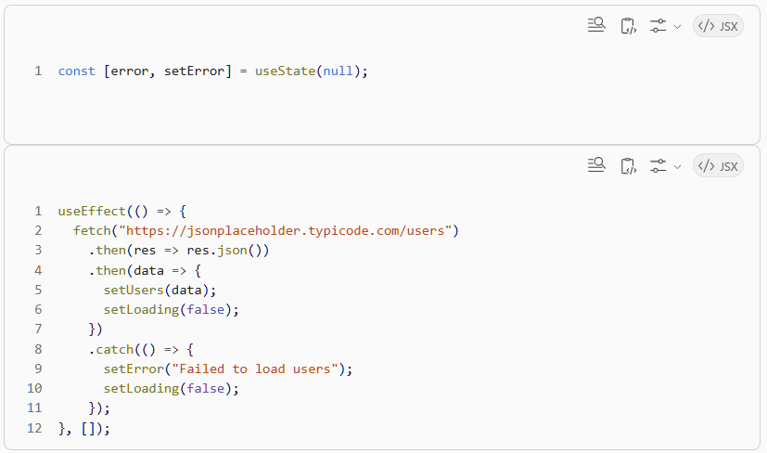
Render:
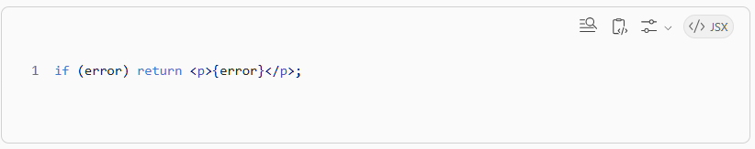
✅ FINAL CODE (clean version)
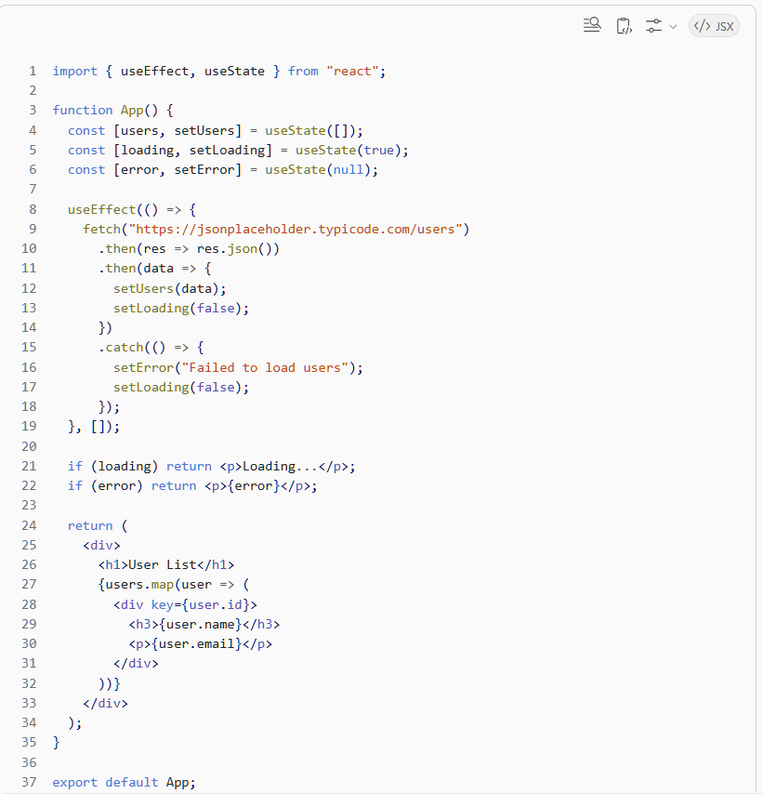

Lab 5
✅ 1. What is React.memo (clean definition)
👉 React.memo is a Higher Order Component (HOC)
✅ Definition:
React.memo wraps a component and prevents it from re-rendering unless its props change.

🧠 Simple meaning
👉 React by default:
Parent re-renders → ALL child components re-render
👉 React.memo says:
Only re-render child IF props changed

✅ Syntax
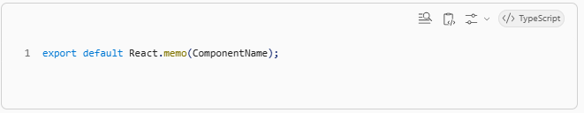
✅ Example
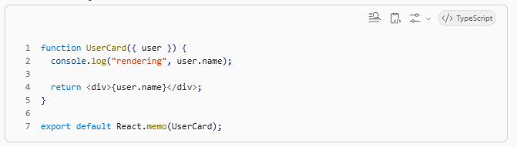
🧠 What argument does it take?
👉 It takes:
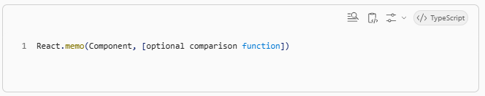
✅ Parameter 1 (required)
Component
👉 The component you want to optimize

✅ Parameter 2 (optional, advanced)
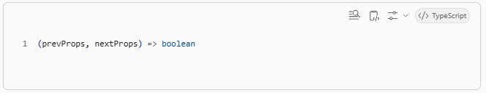
👉 Custom comparison function

🔥 Example with custom comparison
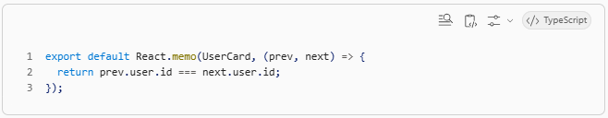
👉 Meaning:
- return true → skip re-render ✅
- return false → re-render ✅

🧠 Default behavior (IMPORTANT)
If you don’t pass comparison function:
👉 React does shallow comparison

✅ What is shallow compare?
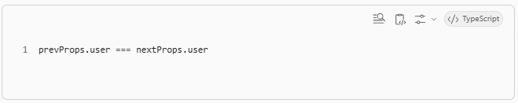
👉 It checks reference, not deep values

❗ Key point (THIS caused your confusion earlier)
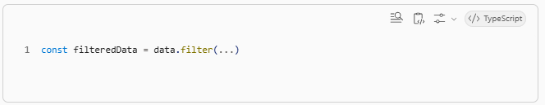
👉 This creates a NEW array each render
So:
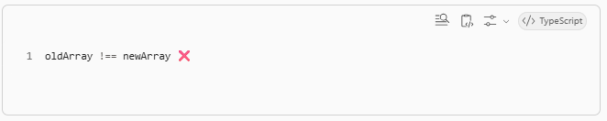
👉 React.memo says:
“props changed” → re-render ❌

✅ Why we used useMemo
To fix this:
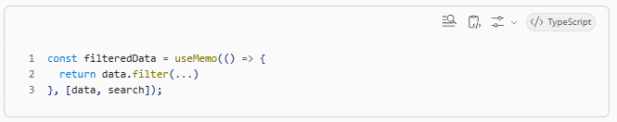
👉 Now array reference stays same until dependency changes ✅

✅ 2. What is useMemo (definition)
✅ Definition:
useMemo caches (memoizes) the result of a calculation and recomputes it only when dependencies change.

✅ Syntax
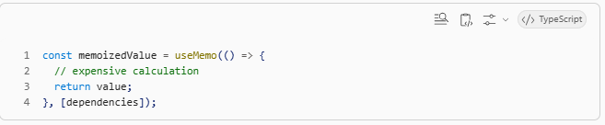
🧠 Meaning
IF dependencies unchanged →
return cached value ✅
ELSE →
recompute ✅
✅ Example
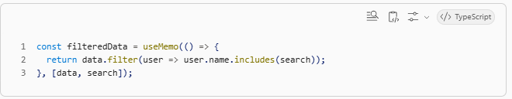
❗ Important
👉 Without useMemo:
filter runs every render ❌
new array every render ❌
👉 With useMemo:
filter runs only when needed ✅
array reference stable ✅

🔥 Full picture (VERY IMPORTANT)

❌ Without optimization
Parent re-render →
new filteredData →
UserList props change →
UserCard re-renders ❌

✅ With useMemo + React.memo
Parent re-render →
filteredData SAME (if no change) →
props SAME →
UserCard skip render ✅

🧠 Clear roles
Concept | Role
React.memo | prevent re-render
useMemo | prevent recomputation
key | identity tracking

🔥 Interview-level answer
If interviewer asks:
❓ What is React.memo?
It is a higher-order component that memoizes a component and avoids re-rendering if props do not change.

❓ What does it accept?
It takes the component and optionally a custom comparison function to control re-rendering.

❓ What is useMemo?
It memoizes the result of a computation and recalculates it only when dependencies change.

👍 Final clarification (your earlier doubt)
You were right:
“Filter still runs on every render”
👉 ✅ TRUE (without useMemo)
👉 That’s why: 👉 React.memo alone is NOT enough 👉 You need useMemo + React.memo together

